Using GitHub for Programming Assignment 2
I started creating this cheat sheet after I read our Programming Assignment and realized using GitHub was going to be a problem for me. I figured out how to do what is necessary for the assignment and then started this cheat sheet so that I wouldn’t forget. Partway through I realized this would probably be a good thing to share with the class, as I’m sure I’m not the only one who is a little lost with GitHub.
Below you will find the GitHub instructions for Programming Assignment 2 in bold. I’ve added my comments in italics and LOTS of screen shots. I use Windows, GitHub Desktop, and R Studio, so apologies to those on different systems or without those programs. Hopefully this will still be some help, or you can add instructions so they are. My name is Becca. My GitHub username is HelpfulMe.
From: https://github.com/rdpeng/ProgrammingAssignment2

In order to complete this assignment, you must do the following:
- Fork the GitHub repository containing the stub R files at https://github.com/rdpeng/ProgrammingAssignment2 to create a copy under your own account.
Log into your GitHub account
Go to the Programming Assignment website, hit Fork
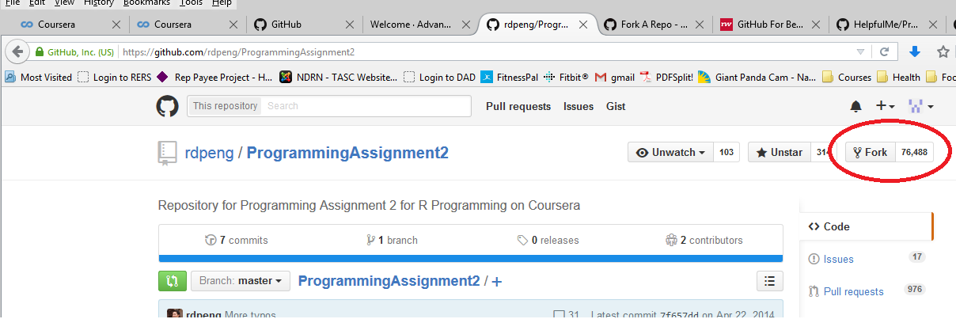
Congratulations! You have a copy of ProgrammingAssignment2 in your GitHub account!

- Clone your forked GitHub repository to your computer so that you can edit the files locally on your own machine.
On your computer, download and install GitHub Desktop (https://desktop.github.com/ )
Log into the GitHub on your GitHub Desktop (open it and follow its directions).
On your GitHub Desktop, select the “+” sign in the upper left corner
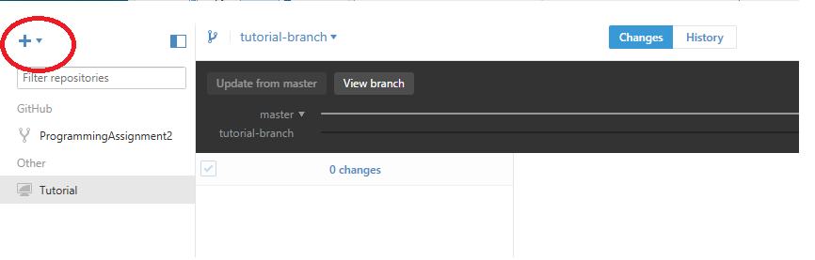
Under the “+”:
- select your Git account (mine is called “HelpfulMe”)
- select “Clone” from the menu options
- select “ProgrammingAssignment2” from the repositories displayed
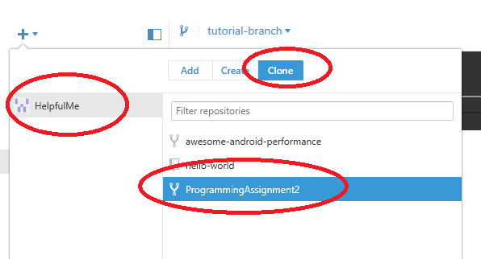
Select the “Clone” button at the bottom (yours will say “Clone ProgrammingAssignment2”, but since I have already cloned the assignment I had to use a different repository to show the text.

Choose where you want to save the files on your computer (it is ok to save them somewhere besides your GitHub folder)
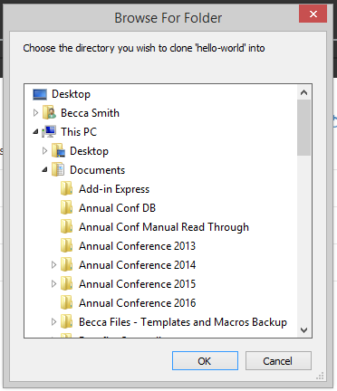
Hooray! The ProgrammingAssignment2 files are on your computer!

- Edit the R file contained in the git repository and place your solution in that file (please do not rename the file).
Close or minimize GitHub, and browse to where you saved the files. (mine are saved in my “R” folder, where I have a separate folder for this Programming Assignment. I have a few extra files in mine because I’ve been playing with this.)
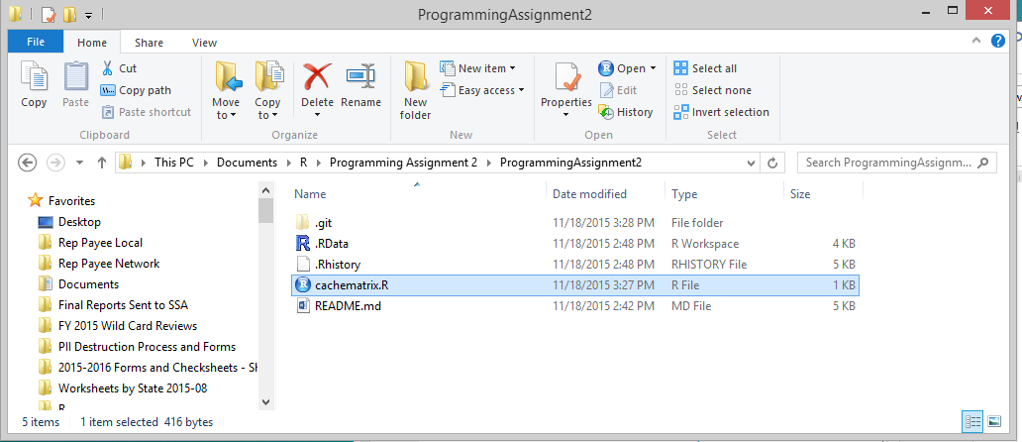
Time to play with R!
Click on cachematrix.R to open R and start coding our programming assignment!
Since we are just playing with this to learn how to use Git and GitHub, I’m just going to add a comment and save it. (I use R Studio, your screen might look a little different)
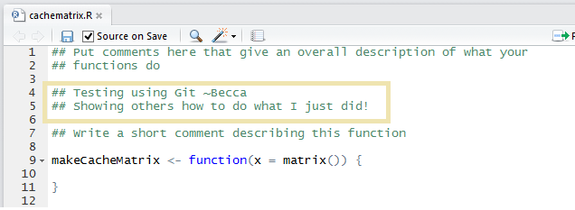
Save your changes.

- Commit your completed R file into YOUR git repository and push your git branch to the GitHub repository under your account.
After you save your changes, close R and go back to the GitHub Desktop on your computer.
Under “ProgrammingAssignment2” look at “Changes”
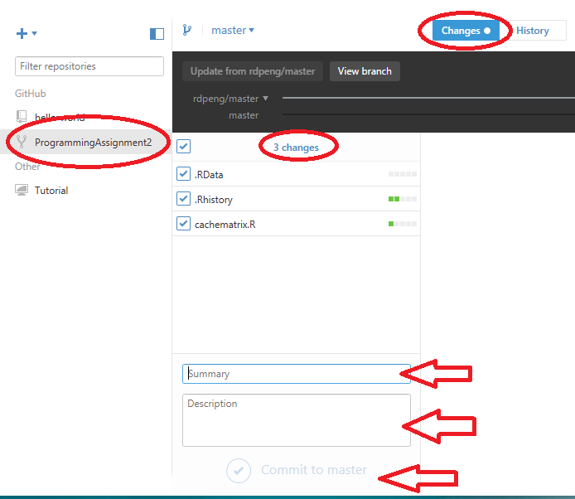
Your “Changes” menu should have turned blue and any files that you changes in that folder (ok, we are in GitHub world now, that ‘repository’) will show up with the option of saving (‘commit’) them.
To “Commit” the changes, give a name to the changes you made. This is a meaningful name for you. I’ll call mine “Teaching” and give it a short description. (You cannot “commit” without giving your changes a name! The ‘description’ is optional)
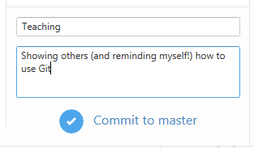
Select “Commit to master”
Whoo hoo! Your changes (and updated files) are saved! In GitHub Desktop, anyway.
BUT they are not yet online.
Next, we need to get them to our online GitHub account. How to do this? Sync!
In the GitHub Desktop, select the “History” tab. This shows the different “Commits” you have made.
Hit the “Sync” button in the upper right corner.
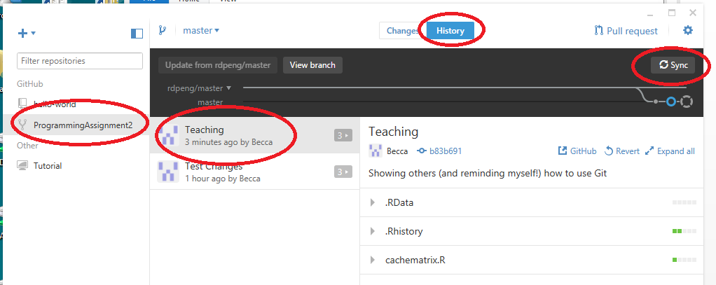
Hooray! Now your updated files are online, in your GitHub account, and shareable!
How do you see them? Hit “GitHub” with the arrow coming out of a rectangle to go to your repository online.
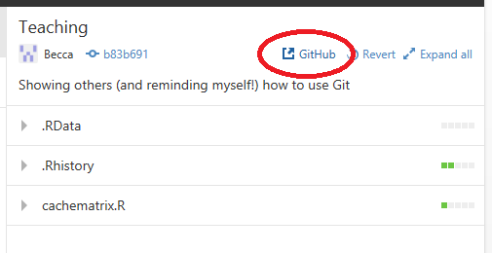
It will open up your browser with that “commit” showing:
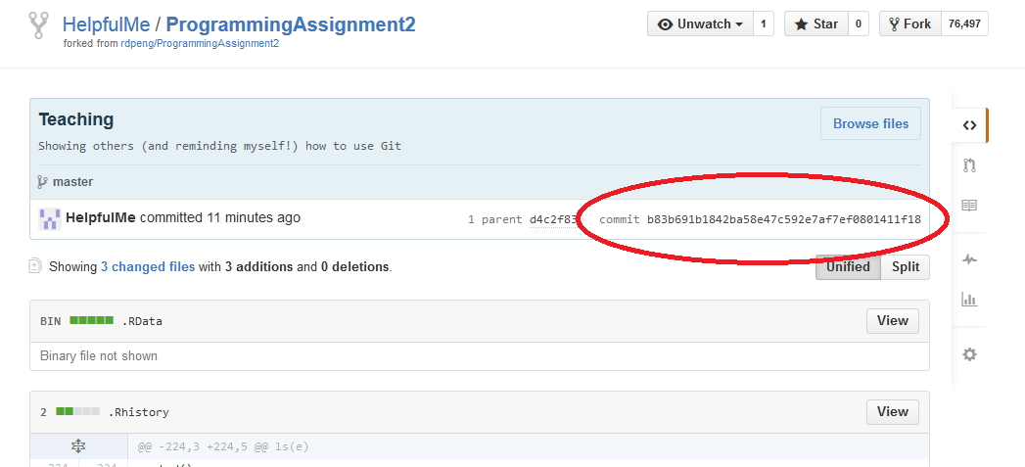

- Submit to Coursera the URL to your GitHub repository that contains the completed R code for the assignment.
And were you wondering where the nice, long letter and number string we need to paste with our programming assignment was going to come from? There it is! Just copy and paste from your final “commit”. (you can also check your browser url: https://github.com/HelpfulMe/ProgrammingAssignment2/commit/b83b691b1842ba58e47c592e7af7ef0801411f18)
So in my case, if this commit had my final solution to the programming assignment, my programming assignment posting will look like:
https://github.com/HelpfulMe/ProgrammingAssignment2
b83b691b1842ba58e47c592e7af7ef0801411f18
For yours, replace “HelpfulMe” with your GitHub username, and the commit crazy long string with the commit string for your final commit.

Good luck! And feel free to submit changes to this document. Although I might have to make another cheat sheet to figure out how to incorporate them!

